COMMUNICATION DATA ASSIGNMENT



TRI UTOMO

X CLASS

L200154006

MUHAMMADIYAH UNIVERSITY OF SURAKARTA

S(t) = A sin(2ft + Ø)

Make a table and drawing it!

Start from t=0.01s until t=1s

For A = 5

Question :

1. f = 5Hz & Ø = 45°

2. f = 5Hz & Ø = 120°

3. f = 10Hz & Ø = 45°

4. f = 10Hz & Ø = 120°

1.For f = 5Hz & Ø = 45°

|  |  |
| --- | --- |
| t(m/s) | S(t) |
| 0.01 | 4.455032621 |
| 0.02 | 4.938441703 |
| 0.03 | 4.938441703 |
| 0.04 | 4.455032621 |
| 0.05 | 3.3535533906 |
| 0.06 | 2.2699524985 |
| 0.07 | 0.782172325 |
| 0.08 | -0.782172325 |
| 0.09 | -2.2699524985 |
| 0.10 | -3.535533906 |
| 0.11 | -4.455032621 |
| 0.12 | -4.938441703 |
| 0.13 | -4.938441703 |
| 0.14 | -4.455032621 |
| 0.15 | -3.3535533906 |
| 0.16 | -2.2699524985 |
| 0.17 | -0.782172325 |
| 0.18 | 0.782172325 |
| 0.19 | 2.2699524985 |
| 0.20 | 3.535533906 |
| 0.21 | 4.455032621 |
| 0.22 | 4.938441703 |
| 0.23 | 4.938441703 |
| 0.24 | 4.455032621 |
| 0.25 | 3.3535533906 |
| 0.26 | 2.2699524985 |
| 0.27 | 0.782172325 |
| 0.28 | -0.782172325 |
| 0.29 | -2.2699524985 |
| 0.30 | -3.535533906 |
| 0.31 | -4.455032621 |
| 0.32 | -4.938441703 |
| 0.33 | -4.938441703 |
| 0.34 | -4.455032621 |
| 0.35 | -3.3535533906 |
| 0.36 | -2.2699524985 |
| 0.37 | -0.782172325 |
| 0.38 | 0.782172325 |
| 0.39 | 2.2699524985 |
| 0.40 | 3.535533906 |
| 0.41 | 4.455032621 |
| 0.42 | 4.938441703 |
| 0.43 | 4.938441703 |
| 0.44 | 4.455032621 |
| 0.45 | 3.3535533906 |
| 0.46 | 2.2699524985 |
| 0.47 | 0.782172325 |
| 0.48 | -0.782172325 |
| 0.49 | -2.2699524985 |
| 0.50 | -3.535533906 |
| 0.51 | -4.455032621 |
| 0.52 | -4.938441703 |
| 0.53 | -4.938441703 |
| 0.54 | -4.455032621 |
| 0.55 | -3.3535533906 |
| 0.56 | -2.2699524985 |
| 0.57 | -0.782172325 |
| 0.58 | 0.782172325 |
| 0.59 | 2.2699524985 |
| 0.60 | 3.535533906 |
| 0.61 | 4.455032621 |
| 0.62 | 4.938441703 |
| 0.63 | 4.938441703 |
| 0.64 | 4.455032621 |
| 0.65 | 3.3535533906 |
| 0.66 | 2.2699524985 |
| 0.67 | 0.782172325 |
| 0.68 | -0.782172325 |
| 0.69 | -2.2699524985 |
| 0.70 | -3.535533906 |
| 0.71 | -4.455032621 |
| 0.72 | -4.938441703 |
| 0.73 | -4.938441703 |
| 0.74 | -4.455032621 |
| 0.75 | -3.3535533906 |
| 0.76 | -2.2699524985 |
| 0.77 | -0.782172325 |
| 0.78 | 0.782172325 |
| 0.79 | 2.2699524985 |
| 0.80 | 3.535533906 |
| 0.81 | 4.455032621 |
| 0.82 | 4.938441703 |
| 0.83 | 4.938441703 |
| 0.84 | 4.455032621 |
| 0.85 | 3.3535533906 |
| 0.86 | 2.2699524985 |
| 0.87 | 0.782172325 |
| 0.88 | -0.782172325 |
| 0.89 | -2.2699524985 |
| 0.90 | -3.535533906 |
| 0.91 | -4.455032621 |
| 0.92 | -4.938441703 |
| 0.93 | -4.938441703 |
| 0.94 | -4.455032621 |
| 0.95 | -3.3535533906 |
| 0.96 | -2.2699524985 |
| 0.97 | -0.782172325 |
| 0.98 | 0.782172325 |
| 0.99 | 2.2699524985 |
| 1 | 3.535533906 |

The graph for f = 5Hz & Ø = 45° :

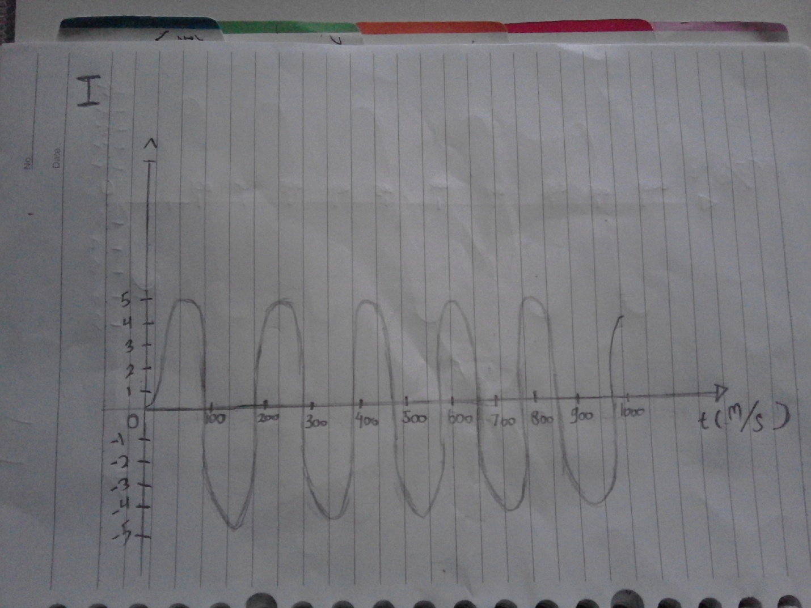

2.For f = 5Hz & Ø = 120°

|  |  |
| --- | --- |
| t(m/s) | S(t) |
| 0.01 | 3.345653032 |
| 0.02 | 2.0336832155 |
| 0.03 | 0.5226423165 |
| 0.04 | -1.039558454 |
| 0.05 | -2.5 |
| 0.06 | -3.7157241275 |
| 0.07 | -4.567727288 |
| 0.08 | -4.972609477 |
| 0.09 | -4.8907380035 |
| 0.10 | -4.330127019 |
| 0.11 | -3.345653032 |
| 0.12 | -2.0336832155 |
| 0.13 | -0.5226423165 |
| 0.14 | 1.039558454 |
| 0.15 | 2.5 |
| 0.16 | 3.7157241275 |
| 0.17 | 4.567727288 |
| 0.18 | 4.972609477 |
| 0.19 | 4.8907380035 |
| 0.20 | 4.330127019 |
| 0.21 | 3.345653032 |
| 0.22 | 2.0336832155 |
| 0.23 | 0.5226423165 |
| 0.24 | -1.039558454 |
| 0.25 | -2.5 |
| 0.26 | -3.7157241275 |
| 0.27 | -4.567727288 |
| 0.28 | -4.972609477 |
| 0.29 | -4.8907380035 |
| 0.30 | -4.330127019 |
| 0.31 | -3.345653032 |
| 0.32 | -2.0336832155 |
| 0.33 | -0.5226423165 |
| 0.34 | 1.039558454 |
| 0.35 | 2.5 |
| 0.36 | 3.7157241275 |
| 0.37 | 4.567727288 |
| 0.38 | 4.972609477 |
| 0.39 | 4.8907380035 |
| 0.40 | 4.330127019 |
| 0.41 | 3.345653032 |
| 0.42 | 2.0336832155 |
| 0.43 | 0.5226423165 |
| 0.44 | -1.039558454 |
| 0.45 | -2.5 |
| 0.46 | -3.7157241275 |
| 0.47 | -4.567727288 |
| 0.48 | -4.972609477 |
| 0.49 | -4.8907380035 |
| 0.50 | -4.330127019 |
| 0.51 | -3.345653032 |
| 0.52 | -2.0336832155 |
| 0.53 | -0.5226423165 |
| 0.54 | 1.039558454 |
| 0.55 | 2.5 |
| 0.56 | 3.7157241275 |
| 0.57 | 4.567727288 |
| 0.58 | 4.972609477 |
| 0.59 | 4.8907380035 |
| 0.60 | 4.330127019 |
| 0.61 | 3.345653032 |
| 0.62 | 2.0336832155 |
| 0.63 | 0.5226423165 |
| 0.64 | -1.039558454 |
| 0.65 | -2.5 |
| 0.66 | -3.7157241275 |
| 0.67 | -4.567727288 |
| 0.68 | -4.972609477 |
| 0.69 | -4.8907380035 |
| 0.70 | -4.330127019 |
| 0.71 | -3.345653032 |
| 0.72 | -2.0336832155 |
| 0.73 | -0.5226423165 |
| 0.74 | 1.039558454 |
| 0.75 | 2.5 |
| 0.76 | 3.7157241275 |
| 0.77 | 4.567727288 |
| 0.78 | 4.972609477 |
| 0.79 | 4.8907380035 |
| 0.80 | 4.330127019 |
| 0.81 | 3.345653032 |
| 0.82 | 2.0336832155 |
| 0.83 | 0.5226423165 |
| 0.84 | -1.039558454 |
| 0.85 | -2.5 |
| 0.86 | -3.7157241275 |
| 0.87 | -4.567727288 |
| 0.88 | -4.972609477 |
| 0.89 | -4.8907380035 |
| 0.90 | -4.330127019 |
| 0.91 | -3.345653032 |
| 0.92 | -2.0336832155 |
| 0.93 | -0.5226423165 |
| 0.94 | 1.039558454 |
| 0.95 | 2.5 |
| 0.96 | 3.7157241275 |
| 0.97 | 4.567727288 |
| 0.98 | 4.972609477 |
| 0.99 | 4.8907380035 |
| 1 | 4.330127019 |

The graph for f = 5Hz & Ø = 120° :

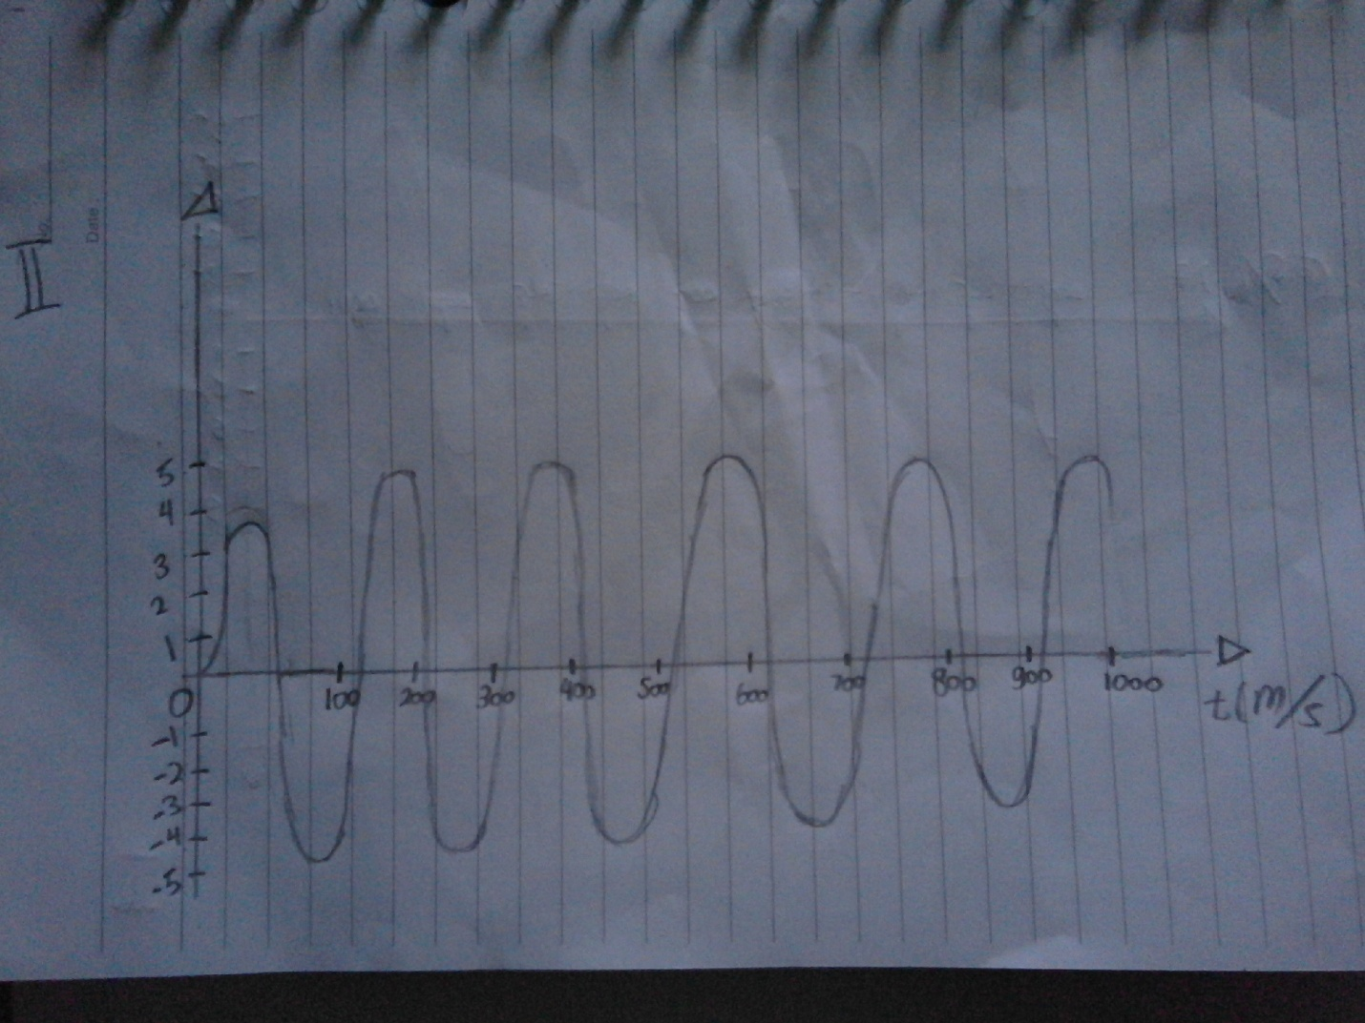

3. For f = 10 Hz & Ø = 45°

|  |  |
| --- | --- |
| t(m/s) | S(t) |
| 0.01 | 4.938441703 |
| 0.02 | 4.455032621 |
| 0.03 | 2.2699524985 |
| 0.04 | -0.782172325 |
| 0.05 | -3.535533906 |
| 0.06 | -4.938441703 |
| 0.07 | -4.455032621 |
| 0.08 | -2.2699524985 |
| 0.09 | 0.782172325 |
| 0.10 | 3.535533906 |
| 0.11 | 4.938441703 |
| 0.12 | 4.455032621 |
| 0.13 | 2.2699524985 |
| 0.14 | -0.782172325 |
| 0.15 | -3.535533906 |
| 0.16 | -4.938441703 |
| 0.17 | -4.455032621 |
| 0.18 | -2.2699524985 |
| 0.19 | 0.782172325 |
| 0.20 | 3.535533906 |
| 0.21 | 4.938441703 |
| 0.22 | 4.455032621 |
| 0.23 | 2.2699524985 |
| 0.24 | -0.782172325 |
| 0.25 | -3.535533906 |
| 0.26 | -4.938441703 |
| 0.27 | -4.455032621 |
| 0.28 | -2.2699524985 |
| 0.29 | 0.782172325 |
| 0.30 | 3.535533906 |
| 0.31 | 4.938441703 |
| 0.32 | 4.455032621 |
| 0.33 | 2.2699524985 |
| 0.34 | -0.782172325 |
| 0.35 | -3.535533906 |
| 0.36 | -4.938441703 |
| 0.37 | -4.455032621 |
| 0.38 | -2.2699524985 |
| 0.39 | 0.782172325 |
| 0.40 | 3.535533906 |
| 0.41 | 4.938441703 |
| 0.42 | 4.455032621 |
| 0.43 | 2.2699524985 |
| 0.44 | -0.782172325 |
| 0.45 | -3.535533906 |
| 0.46 | -4.938441703 |
| 0.47 | -4.455032621 |
| 0.48 | -2.2699524985 |
| 0.49 | 0.782172325 |
| 0.50 | 3.535533906 |
| 0.51 | 4.938441703 |
| 0.52 | 4.455032621 |
| 0.53 | 2.2699524985 |
| 0.54 | -0.782172325 |
| 0.55 | -3.535533906 |
| 0.56 | -4.938441703 |
| 0.57 | -4.455032621 |
| 0.58 | -2.2699524985 |
| 0.59 | 0.782172325 |
| 0.60 | 3.535533906 |
| 0.61 | 4.938441703 |
| 0.62 | 4.455032621 |
| 0.63 | 2.2699524985 |
| 0.64 | -0.782172325 |
| 0.65 | -3.535533906 |
| 0.66 | -4.938441703 |
| 0.67 | -4.455032621 |
| 0.68 | -2.2699524985 |
| 0.69 | 0.782172325 |
| 0.70 | 3.535533906 |
| 0.71 | 4.938441703 |
| 0.72 | 4.455032621 |
| 0.73 | 2.2699524985 |
| 0.74 | -0.782172325 |
| 0.75 | -3.535533906 |
| 0.76 | -4.938441703 |
| 0.77 | -4.455032621 |
| 0.78 | -2.2699524985 |
| 0.79 | 0.782172325 |
| 0.80 | 3.535533906 |
| 0.81 | 4.938441703 |
| 0.82 | 4.455032621 |
| 0.83 | 2.2699524985 |
| 0.84 | -0.782172325 |
| 0.85 | -3.535533906 |
| 0.86 | -4.938441703 |
| 0.87 | -4.455032621 |
| 0.88 | -2.2699524985 |
| 0.89 | 0.782172325 |
| 0.90 | 3.535533906 |
| 0.91 | 4.938441703 |
| 0.92 | 4.455032621 |
| 0.93 | 2.2699524985 |
| 0.94 | -0.782172325 |
| 0.95 | -3.535533906 |
| 0.96 | -4.938441703 |
| 0.97 | -4.455032621 |
| 0.98 | -2.2699524985 |
| 0.99 | 0.782172325 |
| 1 | 3.535533906 |

The graph for f = 10Hz & Ø = 45° :

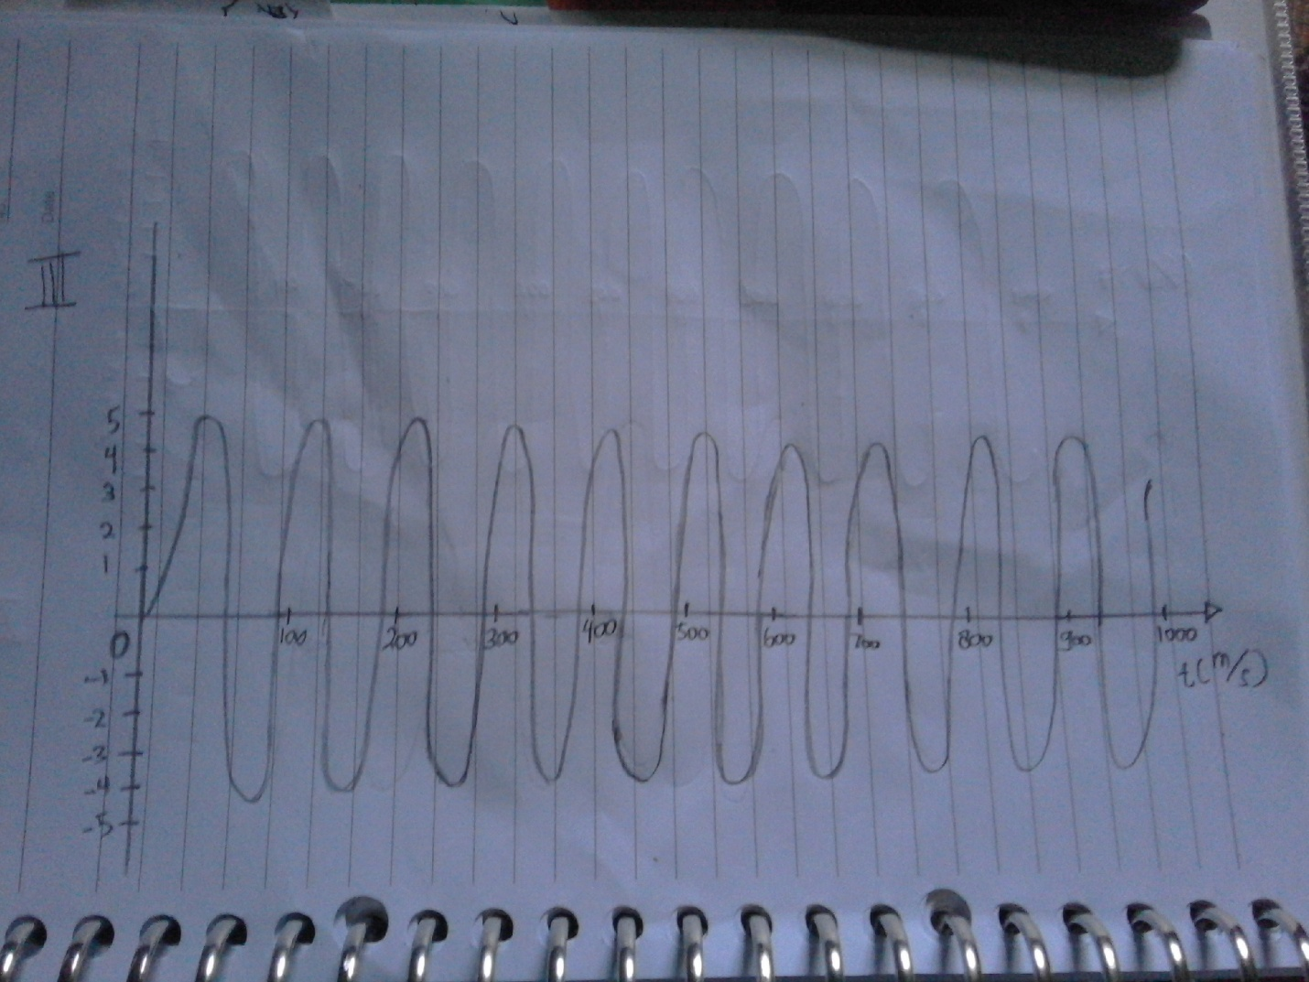

4. For f = 10Hz & Ø = 120°

|  |  |
| --- | --- |
| t(m/s) | S(t) |
| 0.01 | 2.0336832155 |
| 0.02 | -1.039558454 |
| 0.03 | -3.7157241275 |
| 0.04 | -4.972609477 |
| 0.05 | -4.330127019 |
| 0.06 | -2.0336832155 |
| 0.07 | 1.039558454 |
| 0.08 | 3.7157241275 |
| 0.09 | 4.972609477 |
| 0.10 | 4.330127019 |
| 0.11 | 2.0336832155 |
| 0.12 | -1.039558454 |
| 0.13 | -3.7157241275 |
| 0.14 | -4.972609477 |
| 0.15 | -4.330127019 |
| 0.16 | -2.0336832155 |
| 0.17 | 1.039558454 |
| 0.18 | 3.7157241275 |
| 0.19 | 4.972609477 |
| 0.20 | 4.330127019 |
| 0.21 | 2.0336832155 |
| 0.22 | -1.039558454 |
| 0.23 | -3.7157241275 |
| 0.24 | -4.972609477 |
| 0.25 | -4.330127019 |
| 0.26 | -2.0336832155 |
| 0.27 | 1.039558454 |
| 0.28 | 3.7157241275 |
| 0.29 | 4.972609477 |
| 0.30 | 4.330127019 |
| 0.31 | 2.0336832155 |
| 0.32 | -1.039558454 |
| 0.33 | -3.7157241275 |
| 0.34 | -4.972609477 |
| 0.35 | -4.330127019 |
| 0.36 | -2.0336832155 |
| 0.37 | 1.039558454 |
| 0.38 | 3.7157241275 |
| 0.39 | 4.972609477 |
| 0.40 | 4.330127019 |
| 0.41 | 2.0336832155 |
| 0.42 | -1.039558454 |
| 0.43 | -3.7157241275 |
| 0.44 | -4.972609477 |
| 0.45 | -4.330127019 |
| 0.46 | -2.0336832155 |
| 0.47 | 1.039558454 |
| 0.48 | 3.7157241275 |
| 0.49 | 4.972609477 |
| 0.50 | 4.330127019 |
| 0.51 | 2.0336832155 |
| 0.52 | -1.039558454 |
| 0.53 | -3.7157241275 |
| 0.54 | -4.972609477 |
| 0.55 | -4.330127019 |
| 0.56 | -2.0336832155 |
| 0.57 | 1.039558454 |
| 0.58 | 3.7157241275 |
| 0.59 | 4.972609477 |
| 0.60 | 4.330127019 |
| 0.61 | 2.0336832155 |
| 0.62 | -1.039558454 |
| 0.63 | -3.7157241275 |
| 0.64 | -4.972609477 |
| 0.65 | -4.330127019 |
| 0.66 | -2.0336832155 |
| 0.67 | 1.039558454 |
| 0.68 | 3.7157241275 |
| 0.69 | 4.972609477 |
| 0.70 | 4.330127019 |
| 0.71 | 2.0336832155 |
| 0.72 | -1.039558454 |
| 0.73 | -3.7157241275 |
| 0.74 | -4.972609477 |
| 0.75 | -4.330127019 |
| 0.76 | -2.0336832155 |
| 0.77 | 1.039558454 |
| 0.78 | 3.7157241275 |
| 0.79 | 4.972609477 |
| 0.80 | 4.330127019 |
| 0.81 | 2.0336832155 |
| 0.82 | -1.039558454 |
| 0.83 | -3.7157241275 |
| 0.84 | -4.972609477 |
| 0.85 | -4.330127019 |
| 0.86 | -2.0336832155 |
| 0.87 | 1.039558454 |
| 0.88 | 3.7157241275 |
| 0.89 | 4.972609477 |
| 0.90 | 4.330127019 |
| 0.91 | 2.0336832155 |
| 0.92 | -1.039558454 |
| 0.93 | -3.7157241275 |
| 0.94 | -4.972609477 |
| 0.95 | -4.330127019 |
| 0.96 | -2.0336832155 |
| 0.97 | 1.039558454 |
| 0.98 | 3.7157241275 |
| 0.99 | 4.972609477 |
| 1 | 4.330127019 |

The graph for f = 10Hz & Ø = 120° :

